Code for Practical 2

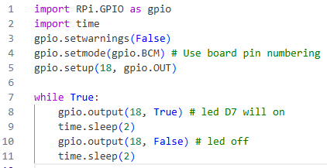
Figure 1: Practice Problem 1
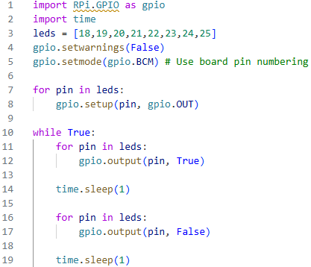
Figure 2 : Practice Problem 2
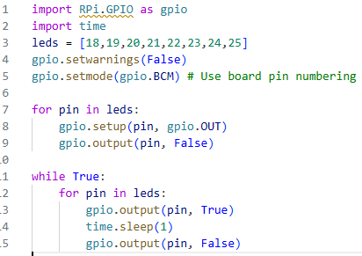
Figure 3: Practice Problem 3

